Resistor sorting robotic arm

We could have an image of our arm here maybe?

|  |  |
| --- | --- |
| Name | Student ID |
| Dominic Pennycook | 19006106 |
| John Nicola | 19007312 |
| Saad Khan | 20010279 |
| James O’Hare | 20023827 |
| Emre Ergun | 19045591 |

Contents

Contents 1

Introduction 3

Purpose of the report 3

Scope of the project 3

All necessary documentation 3

Project management 3

Risks and Management 3

Team allocation 5

Planning and Scheduling 6

Progress monitoring and Coordination 8

High-level design 9

Top-Level System Design 9

High-Level Mechanical Design 10

High-Level Embedded System Design 12

High-Level Software Design 13

High-Level Electrical Design 16

Requirement Analysis 25

Traceability 25

Financial, Regulatory and Intellectual Property considerations 26

Low-Level Design 26

Implementation 26

Low-Level Documentation 38

Electrical 38

Mechanical 38

Traceability 42

Verification and Validation (V&V) 43

V&V Plan 43

Evidence 45

Reflection and Evaluation 45

Strengths of our project 45

Weaknesses of our project 46

Next steps in our start-up 47

What we would do differently next time 47

Appendix 47

References 47

|  |  |
| --- | --- |
| Nomenclature | Meaning |
| RSA | Resistor Sorting Arm |
| V&V | Verification and Validation |
| MVP | Minimum Viable Product |
| V&V | Verification and Validation |
| RMP | Risk mitigation plan |
| WBD | Work Breakdown Structure |
| IPR | Intellectual Property Rights |
|  |  |
|  |  |

# Introduction

## Purpose of the report

Due to the complex nature of the project and the high level of interest from stakeholders, this report was created showing the process’s taken to ensure the product's feasibility and suitability to the problem proposed and the project scope laid out later. Each section will aid in the completion of a future project as well as show the suitable steps in an engineering project's lifecycle that were completed to a high level. Important parts of the project management are included, and the last key section of the report allows a deeper dive into what could be improved for future projects and what lessons were learnt.

## Scope of the project

The resistor sorting arm (RSA) needed to quickly and accurately sort through a group of resistors with minimal human assistance. The arm needed to measure resistor resistance in a set location, pick the resistor up and move it to the correct box. While our MVP works with the E12 resistor series modifications to the code would allow an easy change to a different set of resistors and more additional boxes could be added allowing more different resistors to be sorted.

## All necessary documentation

GitHub was used extensively throughout the project allowing all pertinent documentation to be stored in one location. The use of software similar to GitHub allows excellent version control and advanced team collaboration and allows individuals to produce documentation at their own rate. The GitHub repository is included as a .zip file with this document.

# Project management

## Risks and Management

Initially, a comprehensive list of all related risks was created, throughout the project, risks were added when necessary, and each team member regularly reviewed the plan while making sure it was still suitable. The risk was categorised using Figures XX & XX2, using conditional formatting in excel it was it was simple to understand which risks were most dangerous to the project. Each of the initial risks was used in creating the Gantt chart and allowing additional time for events which had a higher likelihood of being delayed. When a new risk was encountered and added to the mitigation plan, if necessary, this was reflected in the Gantt chart.

Figure 1 - Risk Characterisation Table

Figure 2 - Risk Key

Figure 3 - Risk's and Mitigation Plans

The Verification and Validation (V&V) plan (covered later in this report) was vital to the success of the project. V&V allowed the confirmation that all sections accomplished were traceable to the system and high-level design, without adding unnecessary aspects to the project. As V&V was so vital to the project the robust plan was formed early on and rigorously maintained throughout the venture. Further evidence for the need for a V&V is the need to keep to a strict time budget, delays due to focusing on incorrect parts of the project can cause huge issues and even lead to the cancellation of projects. In addition to time budget, in a start-up situation, an insufficient V&V plan would also lead to a loss of money and in the early stages of a start-up business the budget is incredibly weak.

Legal and contractual issues lead to the production of the minimum viable product (MVP) only using the Lynx motion arm as a base and every part used to modify it was conceived and created within the group, all intellectual property is owned by the business and protected and discussed in the Financial, Regulatory and Intellectual Property considerations section of this report. Economic issues are largely out of the control of the start-up, however suitable mitigation in the case of an issue such as a global pandemic is still needed and provided. Through continued discussion with the stakeholders, described in the stakeholder analysis section, there is an undersaturated market for this product and minimal competition. However, if the market decreased/becomes oversaturated this could financially cripple the company so continued talks are necessary to keep the project being of use to the stakeholders. As with any product, a suitable look into health and safety in the manufacture and use of the product is necessary and the necessary documentation was meant to be completed by the Technical Administrator however they failed to submit the documents in time.

The risk mitigation plan (RMP) was regularly updated in conjunction with the project and GitHub was used for version control ensuring all different stages of the plan were saved and could be accessed if needed. As the RMP was created originally at the beginning of the project all team members knew what the risks were and how to avoid them happening to allow the project to complete smoothly with minimal issues. The Project manager periodically assessed the RMP and concluded whether it was still valid or needed updating.

## Team allocation

At the start of any project, it is vital to determine and define the team structure and roles, making sure everyone in the team understands their role and responsibilities. This breakdown is detailed in figure 4. To further emphasise each team member's responsibilities a responsibility matrix was created (Figure 5). This level of planning allowed team members to know what they needed to complete and who had the information to help them, also allowing individual members to make sure everyone else had completed their section.

Figure 4 – Team structureA screenshot of a computer

Description automatically generated

Figure 5 - Responsibility matrix

## Planning and Scheduling

At the onset of the project the initial version of the Gantt chart was created, figure 6. Throughout the project, some activities took less time than expected and some took a greater time, these combined with unexpected risks significantly altered the project plan. This use of the Gantt chart allowed easy knowledge of where in the project the team should be, while altering it, when necessary, allowed the greatest efficiency. There were no times when team members were overworked or underworked creating good team morale and allowing enough time to be dedicated to individual sections of the project, leading to a high-quality MVP being created within time and budget limitations.

The utilisation of a WBS, figure 8, displayed role paths, and the process needed to get to the final design and the MVP. The use of the co-design principle can be seen in figure 8, this allowed each member of the team to be busy at the same time rather than wasting time waiting, this is more obvious on the project Gantt chart, but the WBS shows a more direct path between the separate disciplines present in this multi-faceted project. The co-design strategies allow all faculties of the project to work in conjunction rather than in a row, as the mechanical design is being created the code can be written and the electronics can be planned and necessary purchases made.

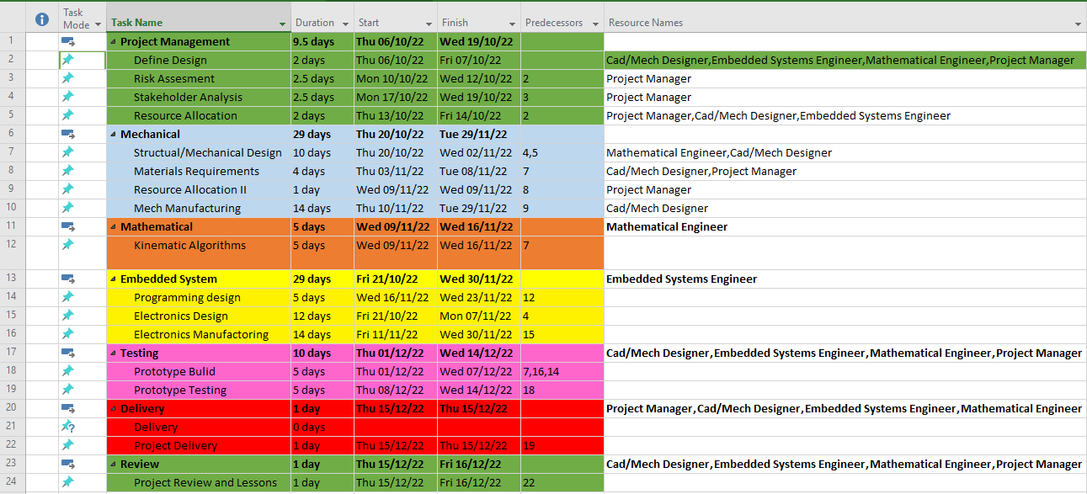

Figure 6 - Project Gant Chart 1

Figure 7 - Project Gant Chart 2

Figure 8 - Work Breakdown Structure

## Progress monitoring and Coordination

During the weekly project meetings, comprehensive meeting minutes were taken, as seen in the GitHub repository, detailing; attendance, what was discussed in the session and what each member needed to complete by the next meeting. This allowed everyone to know what had been discussed and what they need to complete to stay on track and complete the project in time, with everyone contributing and each discipline of the project being completed in good time to minimise delays. Activities were reviewed at the beginning of meetings and if completed to a satisfactory standard were signed off by each present team member, tasks that were not completed for any reason were discussed between the project manager and other members and either moved to the next weeks minutes or altered so the workload was shared and completable. The project manager followed up with help to make sure these tasks were completed during a suitable time frame. This use of meeting minutes on GitHub gave clear instructions to every team member on what was necessary to be completed, when uploaded to GitHub the meeting minutes document was available to everyone and any changes that were made would be visible, each change made a new version which could be accessed at any time utilising GitHub’s version control.

# High-level design

## Table Description automatically generatedTop-Level System Design

Top-level system design and high-level design require an in-depth conversation with the stakeholders, to ensure all stakeholders have considered each team member had a template stakeholder analysis, figure 9, which allowed multiple stakeholders and their importance along with other metrics which decided their allocation in the stakeholder management document. With each team member independently conducting a stakeholder analysis the likelihood of a potential stakeholder being missed is drastically reduced allowing more exhaustive management of the stakeholders. All members included the electronics technical help team at the University of the West of England as a key stakeholder providing the unique possibility to have their opinion every week during the meetings held. This close management of a key stakeholder allowed the project to stay on track and gave a very good system and high-level design criteria.

Figure 9 - Stakeholder Analysis

Utilising the stakeholder analysis and either talking directly to the stakeholder or using the tutor as that stakeholder a list of all the requirements (figure 10) was created and the stakeholder sign-off was used. This stakeholder requirements analysis created the requirements list document which allowed for a clear view of what was desired by the clients and what was needed to complete the project to a high level of satisfaction. Once the stakeholders, the UWE Fet Team and a representative of the hobbyist's group, had read the requirements list any changes were made and the document was signed off. The requirements meant that three sub-systems were needed – Mechanical, software and electrical sub-systems. The Mechanical sub-system will control the redesign of the arm, the new gripper, the wooden base and the kinematic algorithm used to move the arm. The software subsystem will translate the kinematic algorithm created in the mechanical subsystem into computer code for the controller configured in the electrical subsystem, programming for the resistor testing system, as well as any other programming needed i.e. Bluetooth control. The electrical subsystem will configure the setup for the processor, electromagnet, resistor testing circuit, peripheral components and then any wiring and A screenshot of a computer
calibration.

Figure 10 - Requirements list

## High-Level Mechanical Design

The key change made to the arm was the gripper design, the team went through multiple iterations of designs after having completed a comprehensive concept development document as seen in the GitHub repository. These rudimentary designs can be seen in figure 11 and the “GDIP – Concept development.xlsx” document. Each representative reviewed every proposed gripper design and conditional formatting was used to graphically display which was the best design.

Figure 11 - Concept Development

Block Diagram with modified mechanical robotic arm components:

Robotic Arm

Extended Arm

Servo Motor

Modified Electromagnetic Gripper

Figure 12 - Mechanical block diagram

The base board serves as a reference for the arm and a template for where to place the boxes the resistors will get sorted into. It allows the arm to know where to pick the resistors up from and where to place them, ensuring that the arm can operate in the time scale necessary for the stakeholders. The board allows the arm to be moved and always know where it needs to operate which makes operation easier for the user. The major downside of this design is it is large and won’t fit in every laboratory or on every desk, this is of minimal importance as the stakeholders required this size and if there is demand for a smaller one through further stakeholder analysis conversion would be simple.

## High-Level Embedded System Design

First, the documentation for the Lynxmotion ‘SSC-32u’ arm controller board was analysed. The control system uses a UART serial connection to receive control commands and to send some return data back as well. The UART connection could be configured to a desired baud rate and then controlled from any other device with a serial port.

A basic serial message to move all the servos on the robot arm can be sent in the form of a string, beginning with # and ending with a carriage return <cr>

#0P1425#1P1500#2P1500#3P700T2000<cr>

The first part of the command:

#0P1425

#0 means that servo 0 is being controlled, and then p1425 sets that servo to that position. So 1P, 2P, and 3P are then controlling another servo.

The last command:

T2000

Sets the travel speed in milliseconds, so in this example, the motors will allow movement to their desired positions in 2 seconds.

The absolute (maximum) control command was measured to be no greater than 34 Bytes, therefore that is the total length of a message in our system and memory allocation considerations going forward were based on that measurement.

To read the value of resistors, the gripper design is based on 2 probes which act like ohm meter probes to read the resistance of the gripper and an electro-magnet which then picks the resistor up for it to be sorted to a predefined location. For reliable measurements, the PCB to read the value must be mounted as close to the probes as possible, as noise and resistance could affect the analogue reading over longer distances.

Due to the reliability of serial communication over the working envelope of the robot arm:

*“With appropriate line drivers, a UART can work over long distances: from 15 meters (m) for the RS-232 serial data bus to 1000 m for RS-485 or RS-422 interfaces” (Pini, 2019)*

The proposed design utilises an ohm meter on the arm itself, to read the value of the resistor and increase the reliability of that analogue reading, then send the processed reading to another “master” microcontroller which can then activate the robot arm. This will mean making 2 PCBs, one which could be mounted on the gripper and one to remain at the base acting as a master controller.

Given that the SSC-32u controller used serial messages to control the board, a serial connection would be needed for communication with the gripper and considering that the system may want to have the flexibility to communicate with other devices such as a desktop computer alongside the arm controller. A microcontroller

Due to the recent upsets in the global semiconductor supply chain, accounted for in the risk mitigation plan, certain, more popular microcontrollers, such as STM32F103vgt6 (the core of the STM “blue pill”) and Atmega328p (the core of the “Arduino Nano”) have become increasingly difficult to source, with back order waiting times sometimes over a year. Thus, a microcontroller was chosen that was readily available with no foreseeable break in the supply chain.

## High-Level Software Design

For communication:

* OhmMeter/Mag Board – **Atmega328p**
* Main Board- **Atmega328p**
* SSC-32u – **Atmega328p**
* Desktop PC Serial port

Communication protocol:

Setup:

* **Main board** *INIT position commands***>>** **SSC-32u**

Looping:

* **Main Board** *Move to starting position command* **>>SSC-32u**
* **Main board** *pick up/test position command* **>>** **SSC-32u**
* **Main board** *TEST ohm command* **>>** **OhmMeter/Mag Board**
* **OhmMeter/Mag Board** *Send AvgValue* **>>** **Main Board**
* **Main Board** *MagnetOn* command **>>** **OhmMeter/Mag Board**
* **Main Board** *Move to box position command, based on AvgValue* **>>SSC-32u**
* **Main Board** *MagnetOff* command **>>** **OhmMeter/Mag Board**

Settings:

**Setting 1:**

* **Main board** *send data log* **>>****Desktop PC Serial port**

**Setting 2:**

* **Desktop PC Serial port** *send box assignments* **>> Main board**

**Setting 3:**

* **Main board** *Read ohm meter (for testing)* **>> OhmMeter/Mag Board**
* **OhmMeter/Mag Board** *Return ohm reading (for testing)* **>> Main board**

**Setting 4:**

* **Main board** *Turn magnet on (for testing)* **>> OhmMeter/Mag Board**
* **Main board** *Turn magnet Off (for testing)* **>> OhmMeter/Mag Board**

Figure 12 - xxx

## High-Level Electrical Design

Figure 13 – Main Instruction cycle

OHM METER BOARD

The project required a system of reading values of resistance into a microprocessor, the value then denoting what box to sort the resistor into.

Utilising an analogue to a digital converter (ADC), resistance could be read from an unknown resistor by creating a voltage divider with that and another resistor of known value. Reading the voltage from that divider will give the resistance.

The resistance of known value is not random and does need to be within a relative range of that which is being tested. Thus, a feature which is seen in most multimeters, an auto-ranging feature must be implemented to allow a wide range of values to be read without manually changing the resistor of known value.

The auto-ranging design was chosen, using five PNP transistors, acting as switches between different known values of resistance, due to its small layout size compared to some other methods such as using an analogue multiplexer and some peripheral logic.

The system can be broken down as seen in figure 14.

Figure 14 – Resistor measure system breakdown

Then a schematic was designed using Autodesk Eagle, figure 15.

Figure 15 – Resistor measuring schematic

The PCB was designed in eagle, Figures 16 & 17, and then pushed to fusion 360 to allow 3D mounting holes and supports to be properly aligned.

Figure 16 - xx

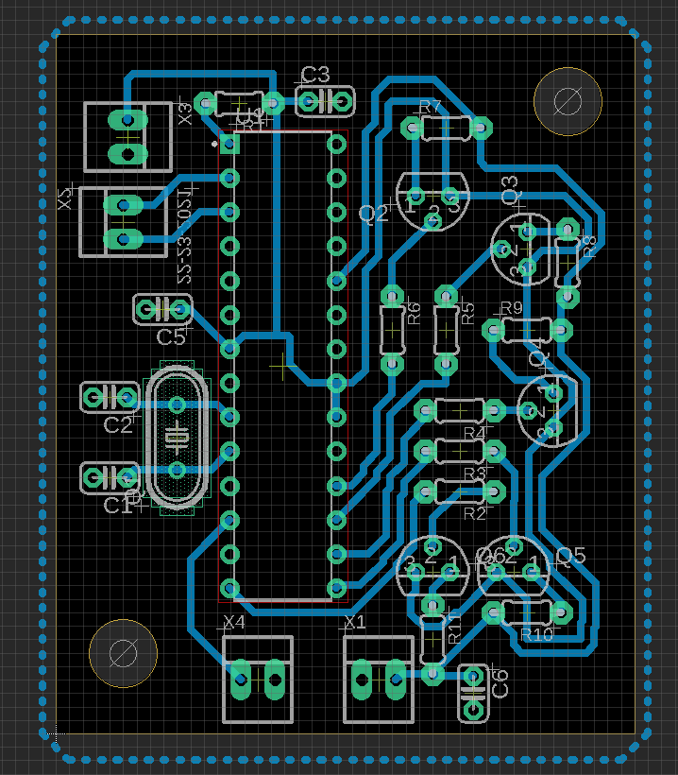

Figure 17 - xx

Mainboard

The main board has a completely different system breakdown as seen in figure 18.

Figure 18 – Main board system breakdown

Autodesk Eagle was utilised again to create the schematic for the main board, figure 19.

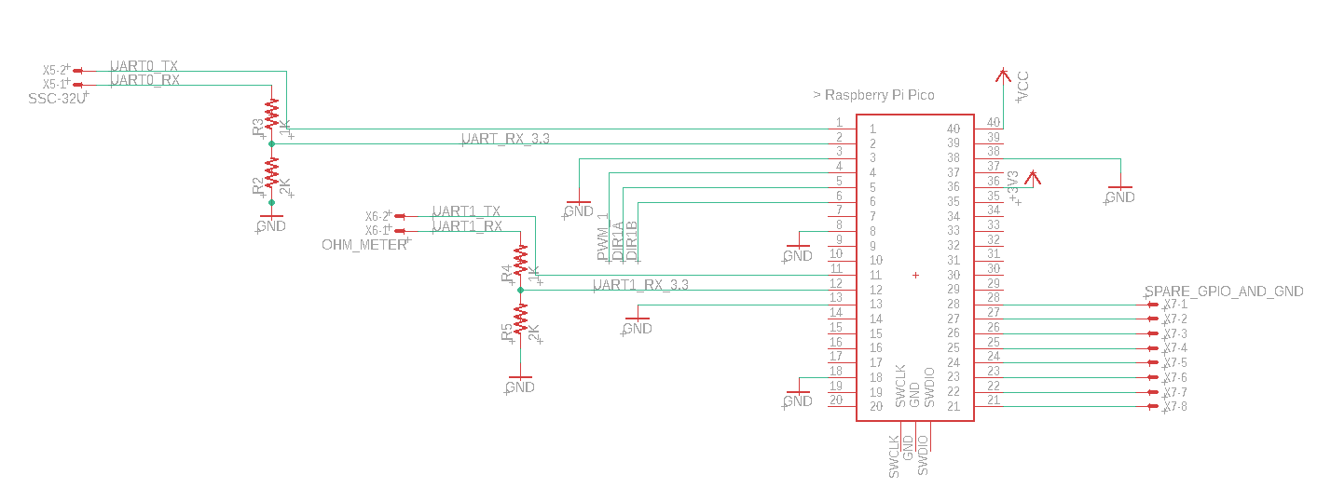

Figure 19 – Main board Schematic

Figure 20 – Complete system breakdown

Figure 21 – Main board schematics

Figure 22 – Gripper Schematic

Figure 23 – Motor Schematic

Figure 24 – Conveyor belt schematic

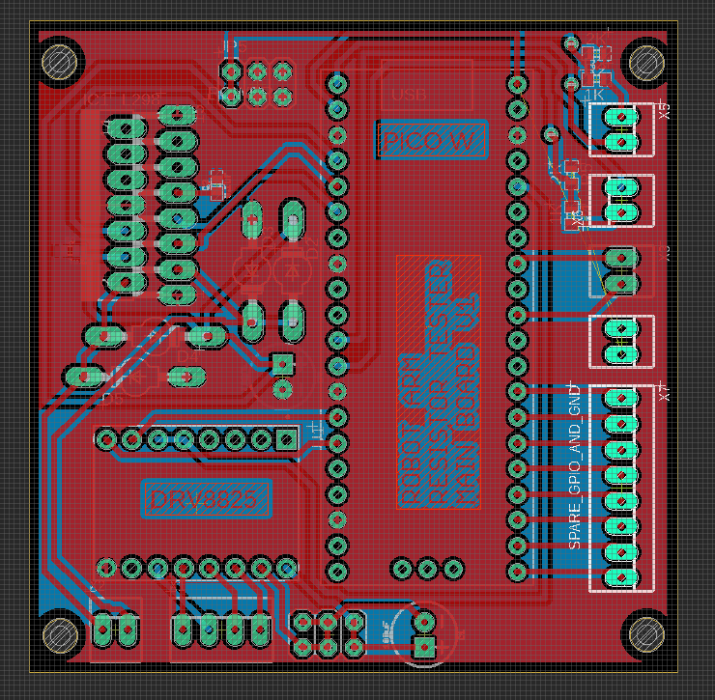

Figure 25 – Resistor measurer PCB main Board

Figure 26 – Resistor measurer PCB main Board

## Requirement Analysis

## Traceability

The High-Level design requirements were specified from user requirements, as corroborated by the Requirements list. This list was formed in collaboration with various stakeholders to produce a comprehensive idea of what the robot was required to complete. Each high-level design has a direct link to system-level design validating that the stakeholders would want it.

# Financial, Regulatory and Intellectual Property considerations

In the UK, to retain intellectual property rights (IPR) over the gripper design and firmware while releasing the other design aspects and firmware as open source, a suitable open-source license was applied to the open-source portions of the project and the gripper design and firmware were kept under a separate, closed-source license.

There are many open-source licenses to choose from, each with different terms and conditions. Some popular open-source licenses include the GNU General Public License (GPL), the MIT License, and the Apache License. These licenses allow others to use, modify, and distribute the open-source portions of the project, but they also include certain restrictions and requirements, such as the requirement to release any modifications made to the open-source code.

To keep the gripper design and firmware closed-source, it was ensured that it was not included in any open-source portions of the project. This means that it was not distributed in any open-source code repositories and that it was not included in any open-source releases of the project. A license file or statement was added to the closed-source portion or a separate license agreement that clearly stated that it is not open-source and that it was protected by the IPR.

Another important step in maintaining IPR was to secure trademarks, patents, or registered designs to protect the gripper design, to prevent others from copying or using it without permission. Consulting with a legal professional was sought to provide a more detailed analysis of the specific case and what steps should be taken.

In summary, open-source licenses were applied, and legal steps were taken to maintain the intellectual property over the gripper design and firmware in the project.

# Low-Level Design

## Implementation

Designing the Base

To ensure the project met requirement 11, readily available storage compartments, sourced from the UWE Electrical Technicians were used. Each storage compartment had dimensions of 54mm by 79mm by 44mm.

Knowing the dimensions of each compartment, the spacing can be determined and therefore we were able to produce the base design.

A custom-built base was designed and manufactured. Wood was selected as the material as it is cheap and readily available. Since there is no significant load carrying or exposure to harsh conditions, this was the optimal choice of material. This helps us to meet requirement 11 from the requirements list.

The base was designed to meet requirement 1 for the minimum working envelope of the robot.

The E12 family consists of 12 values of resistance for each multiple of ten, which means the robot should be able to sort resistors a minimum of 12 different values into storage compartments. From the stakeholder analysis, we can see that UWE laboratory technicians are a very important stakeholder for this project. Knowing this, we decided to have additional storage compartments to facilitate the storage of any resistors that are not in range. As a result, the robot becomes a more convenient product as the user is not limited to only a handful of resistor values. The final design of the base includes 12 storage compartments for resistors, and two additional storage compartments for any resistors that the robot is unable to identify, or whose value corresponds to a resistor value outside of the E12 series. The base design ensures requirement 5 has been met.

Designing a new Gripper

Requirements to be marked against 2,4 and 9

The team produced conceptual sketches shown in figure 11 of gripper designs to meet the requirements listed above. Although all designs met requirement 2, meeting requirement 9 became virtually impossible. This is because designing a gripper that would pick up a resistor by the ends, is extremely difficult and any rotation of the resistor will further decrease the chances of the gripper picking up the resistor. Therefore, to ensure the arm would pick up and sort the resistors correctly over 99% of the time, a new design was required. One that would be able to pick up resistors even when the resistor is not perfectly aligned. To solve this issue, an electromagnet was used to pick and place the resistors. The main advantage of the electromagnet is that the orientation of the resistor becomes a minor concern, as the electromagnet should pick up and place the resistor as required. Requirements 2 and 9 have been met.

The electromagnet gripper, figure 27, meets requirement 4 more efficiently than the other designs in figure 11. The designs consistently illustrate the necessity of movement of the gripper to pick up a resistor. Since there is movement required, the time taken for the process of sorting is increased, reducing efficiency. This is eliminated with the use of an electromagnet since there is no gripper movement required when sorting. Thus, requirement 4 has also been met.

Figure 27 – Prototype Gripper with electromagnet

The electromagnet purchased, figure 28, came with a PCB attached however this would limit its use so it was removed and replaced as described earlier. For the electromagnet to not interfere with the measuring of the resistors, it is turned off during this process. This means the arm moves the gripper and pushes down on the resistor, then the resistor is measured, the electromagnet is turned on and the arm-gripper and resistor move into position above the correct box where the electromagnet is turned off and the resistor is dropped into the correct box.

Figure 28 - Electromagnet

Resistor Feeding Conveyor Belt?

To further improve the chances of meeting objective 4, it was decided that a resistor feeding belt should be made. The user will place all the resistors onto the belt, and the belt would present the arm with the next resistor to sort. To do this, an IR sensor was attached to ensure that the belt stops once a resistor is ready to be sorted. The belt allows for the resistor sorting process to be semi-autonomous, reducing sorting time, therefore allowing us to meet requirement 4 efficiently.

The idea of the conveyor belt was added later on in the project through discussion with the UWE Electrical technicians’ team and allowed the user to place the resistor on a conveyor belt which moved the resistor into the correct place to be picked up by the arm and gripper. This used a light sensor to detect when to stop the belt when a resistor was in the correct location, allowing many resistors to be placed at once and increasing the usability of the project. The conveyor belt used servo motors to move the belt and had a large surface for the resistors.

Measuring the Resistance

To meet requirements 4 and 9, it was decided that the optimum time for measuring the resistance would be before picking up the resistor. This is because it means that we can avoid the extra step of transporting the resistor to a measuring device first, and then placing it in the correct storage compartment. By measuring the resistance before picking and sorting, we have saved time, improving efficiency which helps us to meet requirement 4. Also, there is more time for an error to occur or the resistor to be nudged causing it to drop whilst being transported to a measuring device and then to its box. As well as this, the gripper must pick each resistor up twice before it reaches its destination, which could decrease life expectancy.

Furthermore, there is a possibility that when the resistor is placed on a measuring device, it moves due to its speed or the force it is placed with. This means that the resistor will presumably not be in the same place where it was placed. This means that there is a higher chance of error and a lower success rate. By measuring the resistance before sorting, this is eliminated and requirement 9 is met.

In the following circuit diagram, the resistor being measured is connected between the A1 pin and GND on an Arduino board. A 100nF capacitor is included to steady the voltage across the unknown resistor. The circuit also includes five PNP transistors, which are all the same type (BC559 or 2N3906) and function as electronic switches for the ohmmeter. The emitters of the five transistors are all connected to the 5V pin on the Arduino board. Each transistor's collector is connected to a different resistor, with only one transistor turned on at a time. For improved accuracy, it is recommended that each of the five resistors has a tolerance of 1% or lower. The base of each transistor is connected to an Arduino digital pin via a 4.7k ohm resistor. Additionally, the AREF pin on the Arduino board should be connected to the 5V pin and have a 100nF capacitor between it and the GND pin.

Figure 29 – Resistor measuring schematic

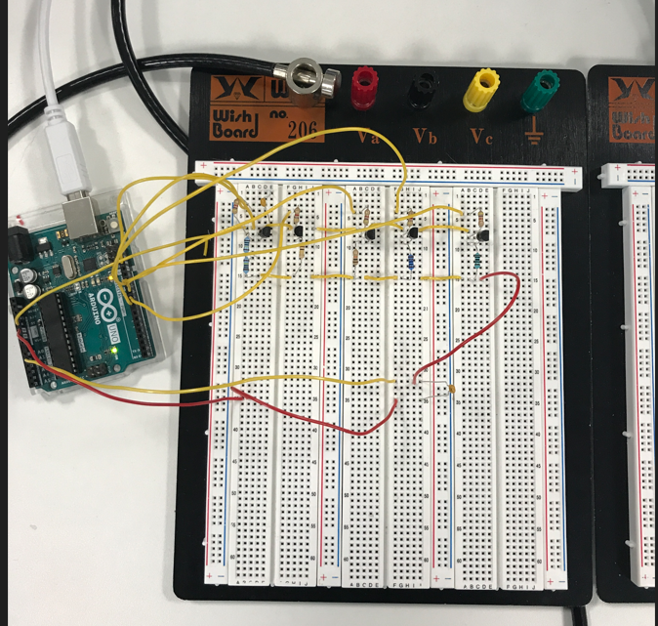The circuit was then tested on a breadboard to check the viability for the project.

Figure 30 – Circuit being tested on a Breadboard

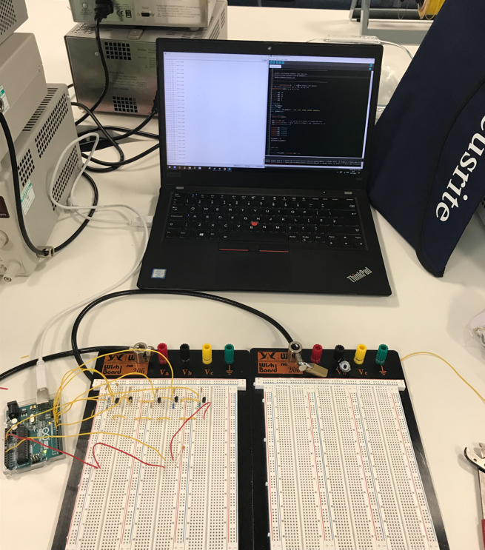

Figure 31 - Circuit being tested on a Breadboard

Then running some test code on Arduino UNO, we confirmed the circuit worked with a decent enough degree of accuracy to achieve the project's 99% match rate goal.

The code runs through a switch case to switch on each of the different known values of resistance until it finds one with a “real” reading.

void ch_select(byte n) {

  switch(n) {

    case 0:

      digitalWrite(CH0, LOW);

      digitalWrite(CH1, HIGH);

      digitalWrite(CH2, HIGH);

      digitalWrite(CH3, HIGH);

      digitalWrite(CH4, HIGH);

      break;

    case 1:

      digitalWrite(CH0, HIGH);

      digitalWrite(CH1, LOW);

      digitalWrite(CH2, HIGH);

      digitalWrite(CH3, HIGH);

      digitalWrite(CH4, HIGH);

      break;

    case 2:

      digitalWrite(CH0, HIGH);

      digitalWrite(CH1, HIGH);

      digitalWrite(CH2, LOW);

      digitalWrite(CH3, HIGH);

      digitalWrite(CH4, HIGH);

      break;

    case 3:

      digitalWrite(CH0, HIGH);

      digitalWrite(CH1, HIGH);

      digitalWrite(CH2, HIGH);

      digitalWrite(CH3, LOW);

      digitalWrite(CH4, HIGH);

      break;

    case 4:

      digitalWrite(CH0, HIGH);

      digitalWrite(CH1, HIGH);

      digitalWrite(CH2, HIGH);

      digitalWrite(CH3, HIGH);

      digitalWrite(CH4, LOW);

  }

  res = res_table[n];

}

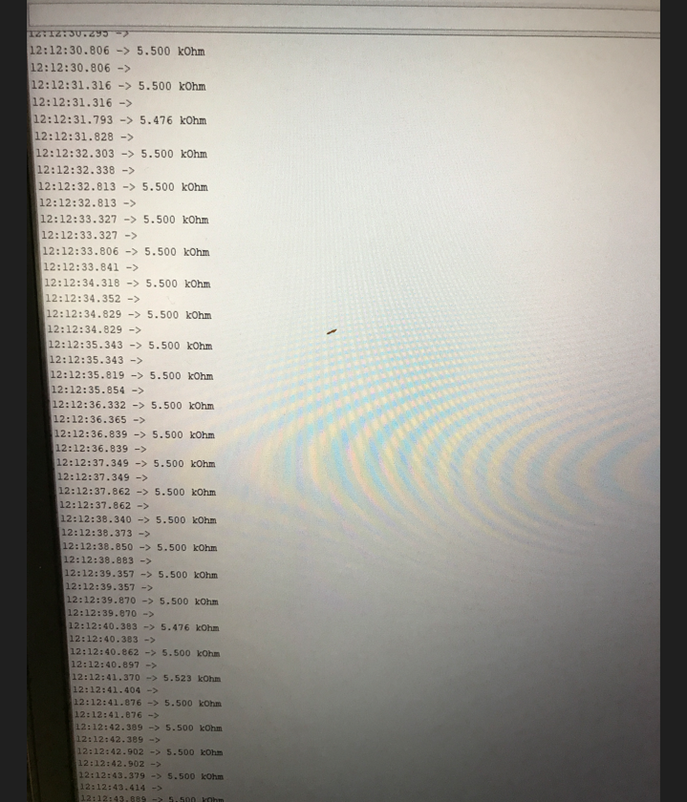

Figure 32 – Test Kilo-Ohm Measurements taken by our gripper

After this, an array was used to store 5 readings, then the mean average could be taken from those 5 readings for an even better degree of accuracy.

Initial test of UART communication to SSC-32u

To test the serial communication protocol, an Arduino Uno was used to verify that the correct commands could be sent as the Arduino platform provided a very quick and easy way of testing this part of the project.

A basic, pseudo-run-through of the commands was written and then implemented on the Arduino Uno without using the kinematic algorithm, just using some basic measurements. The following code was simply designed to move the arm down, engage the electromagnet, move the arm up, hold the resistor for a short period and then disengage the magnet. This allowed for some further development of the physical aspects of the gripper.

    electroMagnetOn();

    delay(1000);

    //Motor 0 to start position

    Serial.println("#0P1500T1000S100");

    //Motor 1 to start position

    Serial.println("#1P1750T1000S100");

    //Motor 2 to start position

    Serial.println("#2P650T1000S100");

    //Motor 3 to start position

    Serial.println("#3P600T1000S100");

    delay(3000);

    Serial.println("#0P1000T1000S100");

    delay(1000);

    Serial.println("#1P1100T1000S100");

    delay(7000);

    electroMagnetOff();

    //move arm down to read resistor

    Serial.println("#0P1500T1000S100");

    Serial.println("#3P800T1000S100");

    delay(5000);

    Serial.println("#2P1500T1000S100");

    Serial.println("#1P1300T1000S100");

    delay(1000);

A crude prototype gripper was developed, figure 32, to enable basic testing of both the electromagnet and ohm meter. This gripper was just 2 plastic blocks, taped in place of the wrist on the AL5D arm. The electromagnet was mounted using an m3 standoff and screw. The ohm meter probes were made using copper tape, with wires carefully soldered to the +/- probes.

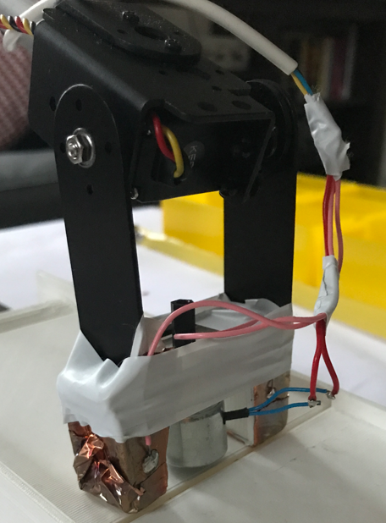

Figure 32 – Crude Prototype Gripper

Each row in this array is in the order, (x, y, resistance in ohms), and can be configured to any value between 100R to 2M

long BoxCoordinatesXY[10][3] = {

    // Row 1

    {0, 260, 1000},       //1k

    {0, 330, 4700},       //4.7k

    {0, 390, 10000},      //10k

    // Row 2

    {80, 270, 20000},     //20k

    {80, 330, 47000},     //47k

    {80, 390, 86000},     //86k

    // Row 3

    {160, 270, 100000},   //100k

    {160, 330, 180000},   //180k

    // Row 4

    {240, 270, 470000},   //470k

    {240, 330, 1000000}}; //1M

Calibration function:

void startAndCalibrateArm()

{

  Serial.println("#0P1425#1P1500#2P1500#3P700T2000\r"); // starting position

  Serial.println("#2PO-100\r");                 // calibrate

  // DEBUG

  delay(2000);

}

Kinematics:

The function uses some basic formulas used within kinematics to determine the angles of the joints of the arm to reach the desired end-effector position. It first calculates the base angle and radial distance from the x, y coordinates.

Next, it calculates the grip offsets based on the angle of the gripper and then uses the grip offsets to determine the wrist position by subtracting the grip offsets from the provided z and y values.

Then, it calculates the shoulder-to-wrist distance and its angle to the ground (a1) and the shoulder (a2). With these values, it calculates the shoulder angle elbow angle and wrist angle in radians and degrees respectively.

Finally, it converts the angle values to servo pulses which are used to control the servo motors of the arm. And it creates a string output with the pulses and a termination command, to output the servo pulses in the format required for the system and returns the string.

The code uses float data types throughout to maintain the highest possible level of accuracy, before then converting back to a long data type.

char *getArmCode(float x, float y, float z)

{

  float grip_angle_d = 68;

  // grip angle in radians for use in calculations

  float grip_angle_r = radians(grip_angle_d);

  // Adjustment so that the gripper hits the floor at z=0;

  z += 70;

  // Base angle and radial distance from x,y coordinates

  // float d = sqrt( x*x + y*y );    //distance from base center to x,y coordinates

  float phi = 90.00;

  float bas_angle_r = atan2(x, y);

  float L = sqrt((x * x) + (y * y));

  // L is y coordinate for the arm

  L -= cos(phi) * GRIPPER;

  y = L;

  // Grip offsets calculated based on grip angle

  float grip_off_z = (sin(grip_angle_r)) * GRIPPER;

  float grip_off_y = (cos(grip_angle_r)) * GRIPPER;

  // Wrist position

  float wrist_z = (z - grip_off_z) - BASE_HGT;

  wrist_z -= sin(phi) * GRIPPER;

  float wrist_y = y - grip_off_y;

  // Shoulder to wrist distance ( AKA sw )

  float s_w = (wrist_z * wrist_z) + (wrist_y * wrist_y);

  float s_w_sqrt = sqrt(s_w);

  // s_w angle to ground

  // float a1 = atan2( wrist_y, wrist_z );

  float a1 = atan2(wrist_z, wrist_y);

  // s_w angle to SHOULDER

  float a2 = acos(((sh_sq - el_sq) + s_w) / (2 * SHOULDER * s_w_sqrt));

  // shoulder angle

  float shl_angle_r = a1 + a2;

  float shl_angle_d = degrees(shl_angle_r);

  // elbow angle

  float elb_angle_r = acos((sh_sq + el_sq - s_w) / (2 * SHOULDER * ELBOW));

  float elb_angle_d = degrees(elb_angle_r);

  float elb_angle_dn = -(180.0 - elb_angle_d);

  // wrist angle

  float wri_angle_d = (grip_angle_d - elb_angle_dn) - shl_angle_d;

  // Servo pulses

  float bas_servopulse = 1500.0 - ((degrees(bas_angle_r)) * 11.11);

  float shl_servopulse = 1500.0 + ((shl_angle_d - 90.0) * 6.6);

  float elb_servopulse = 1500.0 - ((elb_angle_d - 90.0) * 6.6);

  float wri_servopulse = 1500 - (wri_angle_d * 11.1);

  // Set servo pulses

  // create string for output

  // Added some offsets here, not sure if they are correct, they seem to work though

  sprintf(output, "#0P%ld#1P%ld#2P%ld#3P%ldT2000\r", ftl(1500 - bas_servopulse + 500), ftl(shl_servopulse), ftl(elb_servopulse), ftl(wri_servopulse + 400));

  return output;

}

Order of Operations / Sequence Table

|  |  |
| --- | --- |
| Events | Duration / Seconds |
| Power On | 0.5 |
| The user places the resistor onto the conveyor belt | 1 |
| Sensor Detects Resistor | 1 |
| Conveyor Belt Stops | 0.5 |
| Gripper Measures Resistance | 1 |
| Electromagnet turns on | 1 |
| Arm moves to allocated position | 2 |
| Arm returns to start position | 2 |

## Low-Level Documentation

## Electrical

Figure 33 – Raspberry Pi Pico Pinout

Figure 33 is the pinout of the Raspberry Pi Pico used for the main controller for the project

## Mechanical

**Gripper**

Figures 34 and 35 show the in-use gripper design which allows for the mounting of a PCB on the top, an electromagnet and strips of copper to allow for measuring and picking up resistors.

Figure 35 - Robot arm redesigned gripper on Fusion 360 render – Version 3

Figure 34 – Robot arm redesigned gripper on Fusion 360 – Version 3

This was the first variation for a gripper design that allowed for the mounting of a PCB and the electromagnet:

Figure 36 - Robot arm redesigned gripper on Fusion 360 – Version 1

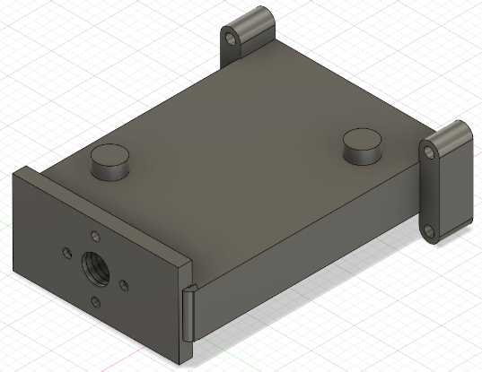

Figure 37 - Robot arm redesigned gripper on Fusion 360 render – Version 1

The second design allows for measuring the resistors by attaching copper strips to the ends and has a section for the electromagnet, however, the initial print was too weak due to a lack of infill, this was rectified in the next print:

Figure 38 - Robot arm redesigned gripper on Fusion 360 – Version 2

Figure 39 - Robot arm redesigned gripper on Fusion 360 render – Version 2

Figure 40 – Version 3 of the Gripper with not enough infill

The difference between versions 1 and 2 of the gripper is that version 1 has not got the prongs for measuring the resistance whereas the second gripper has prongs for mounting copper strips for measuring resistance. Comparing the second gripper to the final iteration of the gripper the main difference is how the gripper is mounted to the arm, the final solution keeps the PCB secured and safe and has space for electromagnet while being able to measure the resistance, fulfilling all the necessary criteria.

Figure 10 - Gripper with not enough infill

**Arm Extension**

This arm extension was designed on fusion 360 and manufactured in the metal workshop at UWE out of the aluminium Frenchay Campus. This was completed to allow the arm to have a 50 cm working envelope.

Figure 41 - Robot arm extension

Figure 42 - Robot arm extension render

The arm extension in figures 43 & 44 was the first version of the extension, however, was manufactured to an excessive length of 500 mm which meant it was too heavy, impractical, and not required which is why the second version was reduced to 203.2mm.

Figure 44 - Initial extension design render

Figure 43 - Initial extension design

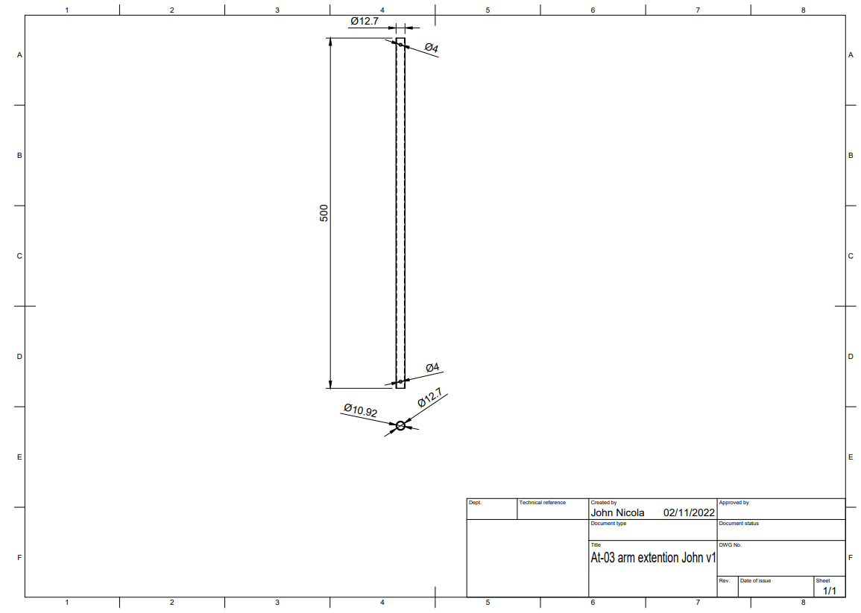

**Base**

The base was simple to design, and once the necessary measurements were taken figure 45 was designed and fulfilled all the criteria for the base

Figure 45 - Engineering Drawing of the base

## Traceability

Throughout the project, in the weekly meetings, the project manager would run through the requirements list and evaluate each member's tasks with respect to traceability. This was aided by the different steps taken in the system – high – low-level design processes. An example is shown in figure 46, where a selection of high and system-level design criteria are listed with their lower-level design requirements directly linked to them. This allows a graphical representation of the traceability of the project ensuring no extraneous developments are made to the project and that every part of the design is of cure to the stakeholders.

Figure 46 - High -> Low-level design with traceability

# Verification and Validation (V&V)

## V&V Plan

The V&V plan, called “Verification and Validation plan.xlsx”, ensures that the product is designed and built well and what the customer desired. To accomplish this a competent V&V plan was created at the onset of the project and strictly adhered to, this relied heavily on the V&V matrix (Figure 47) and the individual sign-off.

A V&V matrix (Figure 47) allows for every key aspect of the project to be officially tested and verified to both work and contribute to what is desired by the stakeholders. Each of the high-level designs and the lead team member(s) are listed with the ID of the verification used and whether this provided full or partial coverage. The different verifications used are found on the next sheet (Figure 48) and these describe the actions taken and are referenced using ID tags for ease of use. The V&V plan was used throughout the project and shows how successful the project was.

Figure 47 - V&V Matrix

Figure 48 - V&V Methods

At the end of each project management document a box is displayed which has a location for each member of the team to sign indicating they have reviewed the document and agreed that it is up to standard. Figure 49 shows the document sign-off box, it is a clear indication that the document has been reviewed and quality checked. In addition to the team member sign off certain documents have a stakeholder sign off which shows a stakeholder has checked the document and that it reaches the standards that are expected (Figure 50). These two boxes verify that what they represent is verified to what is wanted from the customer and also that it is a good solution to the problem.

Figure 51 shows one of the proof of concept renders used as evidence to show how the final part will look, it allows verification that the part will work and validation that the stakeholders agree with the design as it is stakeholder signed off. All of these methods provide evidence that the whole of the project has been quality checked and meets the standards of both the team and the stakeholders.

Figure 49 - Document sign-off box example



Figure 50 - Stakeholder sign off example

Figure 51 – Render of the redesigned gripper with the electromagnet control PCB attached

# Reflection and Evaluation

## Strengths of our project

The project has achieved its goal of picking up, identifying and sorting resistors one by one into different boxes. This allows for a quick and easy method of sorting different value resistors.

When designing the components to be manufactured for the project there were first various designs put forward by different group members to allow consideration for the most applicable approach to be taken. This approach to picking a design allowed for the most unbiased approach as different people could advocate for which idea was better in their opinion. This allowed for the current design to be put forward with copper strips measuring the resistance and an electromagnet picking up the resistors for distribution to the allocated sorting boxes.

The gripper and arm extension also had more than one prototype during their process of development which allowed for the design of each component to be designed and refined till the use case could be easily achieved.

Furthermore, as the gripper design required the highest development time for the mechanical component it was effective that it was constructed out of plastic which means that we could 3d print prototypes with a very short wait time.

## Weaknesses of our project

One limitation in the design process was the timescale. Since the timescale for the project was very short, it was difficult to explore all design options which reduced the range of suppliers we could source our parts and materials from. It is reasonable to assume that the parts that were used in the project could have been sourced from a cheaper source, given a larger timescale, meaning we could have used parts that were of a higher quality for the same price- if not less. This could help in optimising the costs of the project and reduce the likelihood of the budget being used inefficiently. By not being able to do so, our competitiveness in the market is reduced as our competitors may be able to offer a reduced price, due to the lower costs of components. This could mean that our product may not be able to sell as well, leading to difficulty in breaking even or making a profit.

Another limitation in the design process was a lack of freedom when designing to solve a problem. Once the aim of the project was actualised, we were constrained to design a robot arm, which ultimately, hinders the competitive nature of the product. Our product is a pick-and-place robot which sorts resistors into various storage compartments. However, if not constrained to a robot arm, it is possible to create a resistor sorting device that requires less actuation and steps, as opposed to our product. This means that it is possible for a system to complete the same tasks as our robot does, in less time, with fewer movements. This means that, from a consumer perspective, our product could be considered inefficient.

Additionally, we were also limited in the design process due to the nature of the group allocation. Since this was our first group project together, we had no previous interactions with one another. This means that there was not an understanding and bond between members before the beginning of the project. Although this may seem insignificant, this can be critical and a deciding factor in the success of a project. This is because a good working environment can boost the productivity of the whole team and can help deliver a high-quality product.

To create a healthy working environment, we first had to spend time talking and getting to know one another. Without this, there is a possibility of conflicting design ideas within the group, which can slow down the rate of task completion and delay the project's closure.

## Next steps in our start-up

To move from MVP to an actual product that is ready to be sold a robust plan of manufacturing needs to be completed. Finalised designs need to be confirmed and lots of testing and conversing with stakeholders, to make sure no changes need to be made, is required. Once the design is finalised and the manufacturing process is refined then production can start. Marketing is needed to have a successful product and all necessary legal documentation will need writing.

## What we would do differently next time

Greater importance should be applied to the early project management stages to ensure future projects can get completed faster. The use of the co-design principals was good and allowed good, efficient progress, however, there were small periods where people were waiting for others to complete tasks, this could be avoided with better planning, but this is tricky to balance with the other commitments (modules) of the team members.

For future projects, it may be beneficial to conduct primary research to further understand consumer requirements and therefore, design a solution that would serve its purpose more effectively. An additional benefit of conducting primary research would be understanding who the competitors are, and therefore what must be done to outperform them. Although conducting research can delay the success of the project, this may allow us to become more competitive, and therefore increase our market share.

A more extensive and robust V&V plan would be beneficial. This is to further ensure that the design requirements are met and reduce the chances of scope creep. The benefit of this would be reduced likelihood of product failure and less likelihood of exceeding budget. Also, since requirements will be met, the competitiveness of the product will increase leading to greater market share.

For future projects, a more in-depth review of what the customer wants and a more comprehensive V&V plan would be beneficial, this means more stakeholder management, and longer interviews with all stakeholders to give a complete view of what is necessary for the product, and what would be nice to have’s as well.

A more thorough review of the finances and intellectual property would be necessary, however, this work was meant to be completed by our technical administrator, however, they failed to attend more than one weekly meeting or produce any work leading to this void in our report and project.

### References

Pini, A. (2019) *UARTs Ensure Reliable Long-Haul Industrial Communications Over RS-232, RS-422, and RS-485 Interfaces* Digi-Key's North American Editors (ed.) *Digi-Key Electronics*.22 May 2019 [online]. Available from: https://www.digikey.co.uk/en/articles/uarts-ensure-reliable-long-haul-industrial-communications [Accessed 13 November 2022].